**MINISTRY OF EDUCATION AND TRAINING**

**FPT UNIVERSITY**

Capstone Project Document

Football Pitches Booking

|  |  |
| --- | --- |
| **Group 10** | |
| **Group Members** | Nguyễn Duy Phương – SE60761 – [phuongndse60761@fpt.edu.vn](mailto:phuongndse60761@fpt.edu.vn)  Nguyễn Hữu Hoàng Giang – SE60606 – [giangnhhse60606@fpt.edu.vn](mailto:giangnhhse60606@fpt.edu.vn)  Nguyễn Đức Thịnh – 60398 – [thinhnd60398@fpt.edu.vn](mailto:thinhnd60398@fpt.edu.vn)  Nguyễn Quốc Khánh – 60556 – [khanhnq60556@fpt.edu.vn](mailto:khanhnq60556@fpt.edu.vn) |
| **Supervisor** | Lại Đức Hùng |
| **Ext Supervisor** |  |
| **Capstone Project code** | FPB |

- Ho Chi Minh, 01/2014 –

1. Table of Contents

Definitions, Acronyms, and Abbreviations 5

Report No.6 : System User’s Manual 6

6.1 Installation Guide 6

6.1.1 System requirements 6

6.1.2 Installation 6

6.1.2.1 Deploy Database 6

6.2 User’s Guide 12

6.2.1. Website Master 12

6.2.1.1. Join Request Management 12

6.2.1.2. Stadium Management 12

6.2.1.3. User Management 15

6.2.1.4. Advertise Management 18

6.2.1.5 Recommendation Management 19

6.2.1.6 Ranks Management 20

6.2.2 Website Staff 22

6.2.2.1. User Management 22

6.2.3 Stadium Staff 25

6.2.3.1 Promotion Management 26

6.2.3.2 Reservation Management 28

6.2.4 Stadium Owner 32

6.2.4.1 Stadium Management 33

6.2.4.2 Promotion Management 40

6.2.4.3 Reservation Management 41

6.2.5 User 46

6.2.5.1. Register 46

6.2.5.2. Login 47

6.2.5.3. View Account Profiles 48

6.2.5.4. Edit Account Profiles 49

6.2.5.5. Find Available Stadium 50

6.2.5.6. Find Stadium 50

6.2.5.7. View Stadium Details 51

6.2.5.8. Rating Stadium 51

6.2.3.9. Review Stadium 52

6.2.3.10. Booking Pitches 53

6.2.3.11. Cancel Reservation 54

6.2.3.12. Find Rival 55

6.2.3.13. Join Rival 56

6.2.3.14. View Booking History 57

6.2.5.15. Request Join System 58

6.2.5.16 Forgot Password 59

6.2.5.17 Resend mail to activate Account 59

6.2.5.17 Feedback Website 59

6.3. Other [Optional] 60

## Definitions, Acronyms, and Abbreviations

|  |  |  |
| --- | --- | --- |
| No. | Keyword | Definition |
| 1 | B2B2C | Stand for Business to business to customer.  In this system, first business is the organization that provides stadium owner to register their stadiums. The second business is stadium owner, who provides hire stadium service, and customer is the user, who want to hire field by this system. |
| 2 | FPB | Football Pitches Booking |
| 3 | ERD | Entity Relationship Diagram |
| 4 | API | Application Programmable Interface |
| 5 |  |  |

## Report No.6 : System User’s Manual

### 6.1 Installation Guide

#### 6.1.1 System requirements

* Operation system: Windows 7 (32 or 64 bit) or laster
* Memory: 2G RAM or more
* Browser: Firefox v25 or laster
* IIS feature is turned on

#### 6.1.2 Installation

#### 6.1.2.1 Deploy Database

* Run script file “~/FootballPitchesBooking/Database/FootballPitchesBooking.sql” in SQL Server Management Studio.

6.1.2.2 Deploy Application

* Open “Internet information Services (IIS) Manager”.
* Right Click “Sites” folder in left content, select “Add Web Site”.

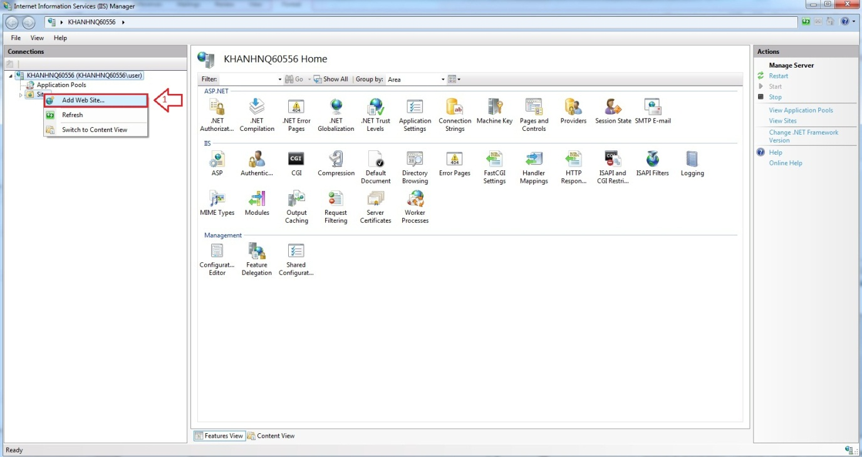

Firgure 6.1 Add Web Site

* Enter “Site Name”.
* Click “Select” button to select Application pool.

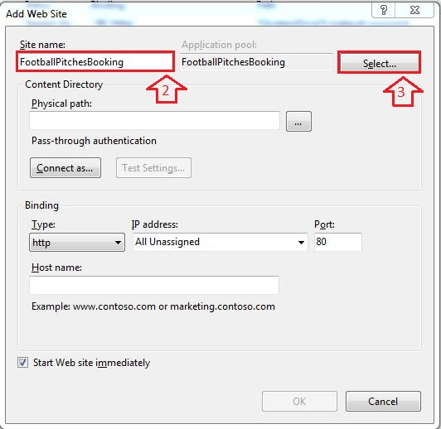

Figure 6.2 Add Site Name

* Select “ASP.NET v4.0”.

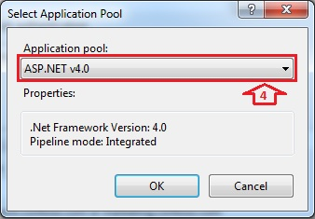

Figure 6.3 Select ASP.NET

* Browse physical path: “~/ FootballPitchesBooking”.

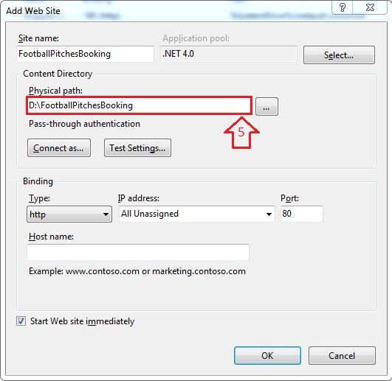

Figure 6.4 Add Path Link

* Open “~/ FootballPitchesBookingProject/Web.config” file by Notepad.

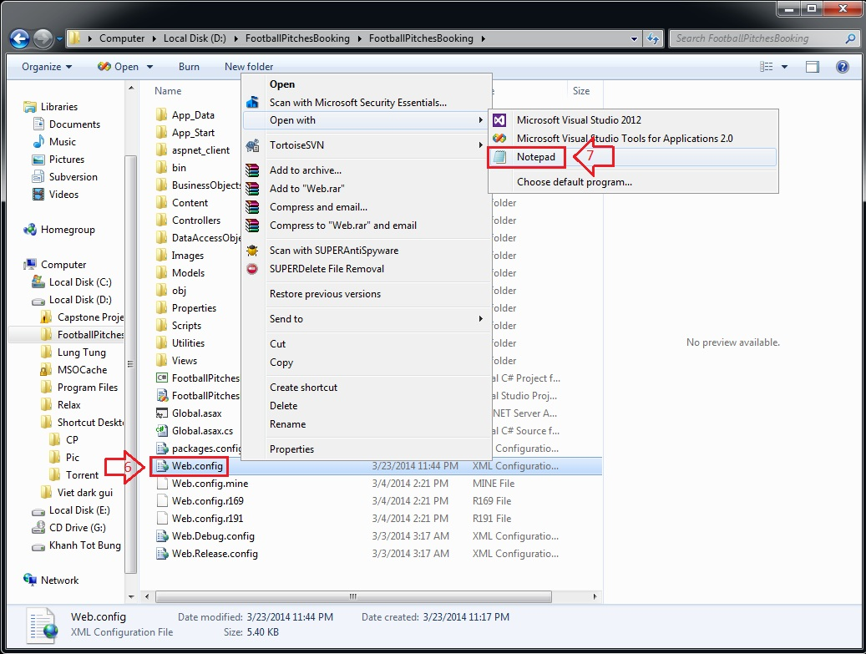

Figure 6.5 Edit Web.config

* Find “connectionStrings” tag, change “Server Name”, “User ID” and “Password” in its connection string depend on your computer.

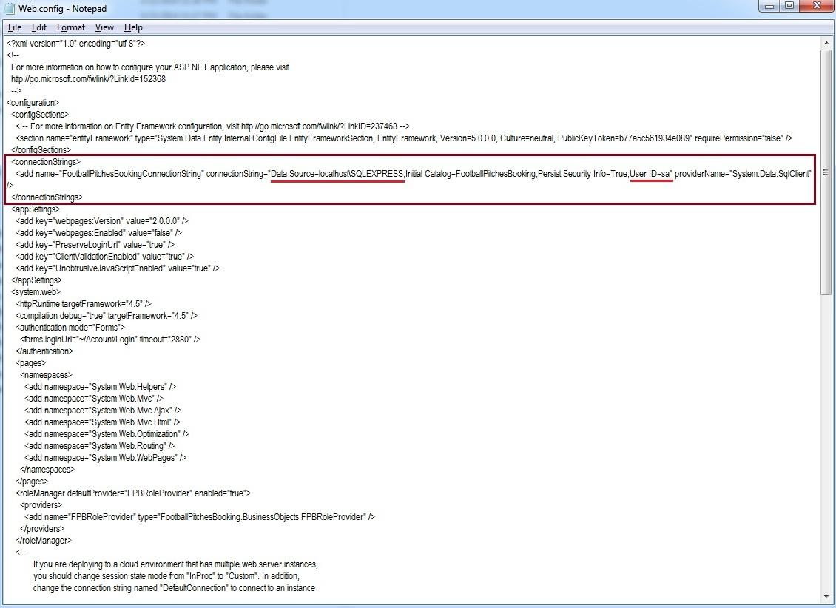

Figure 6.6 Edit Web.config

* Right Click new site name (FootballPitchesBooking) in left content -> Manage Web Site -> Browse to view the website.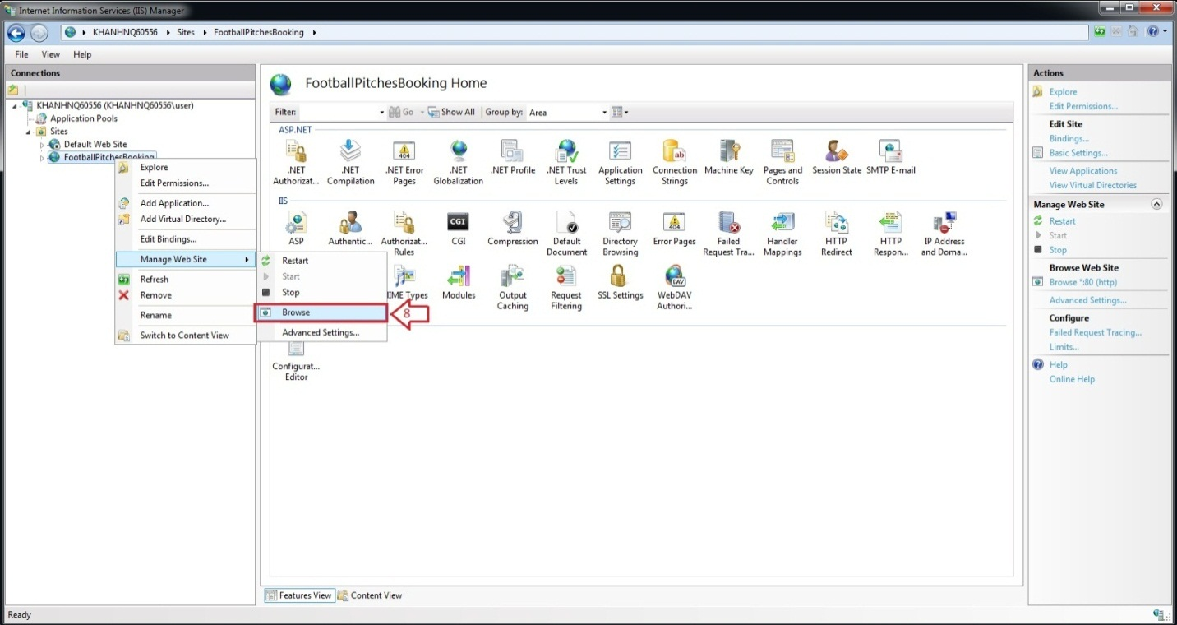

Figure 6.7 How to open Website

* The website is deployed.

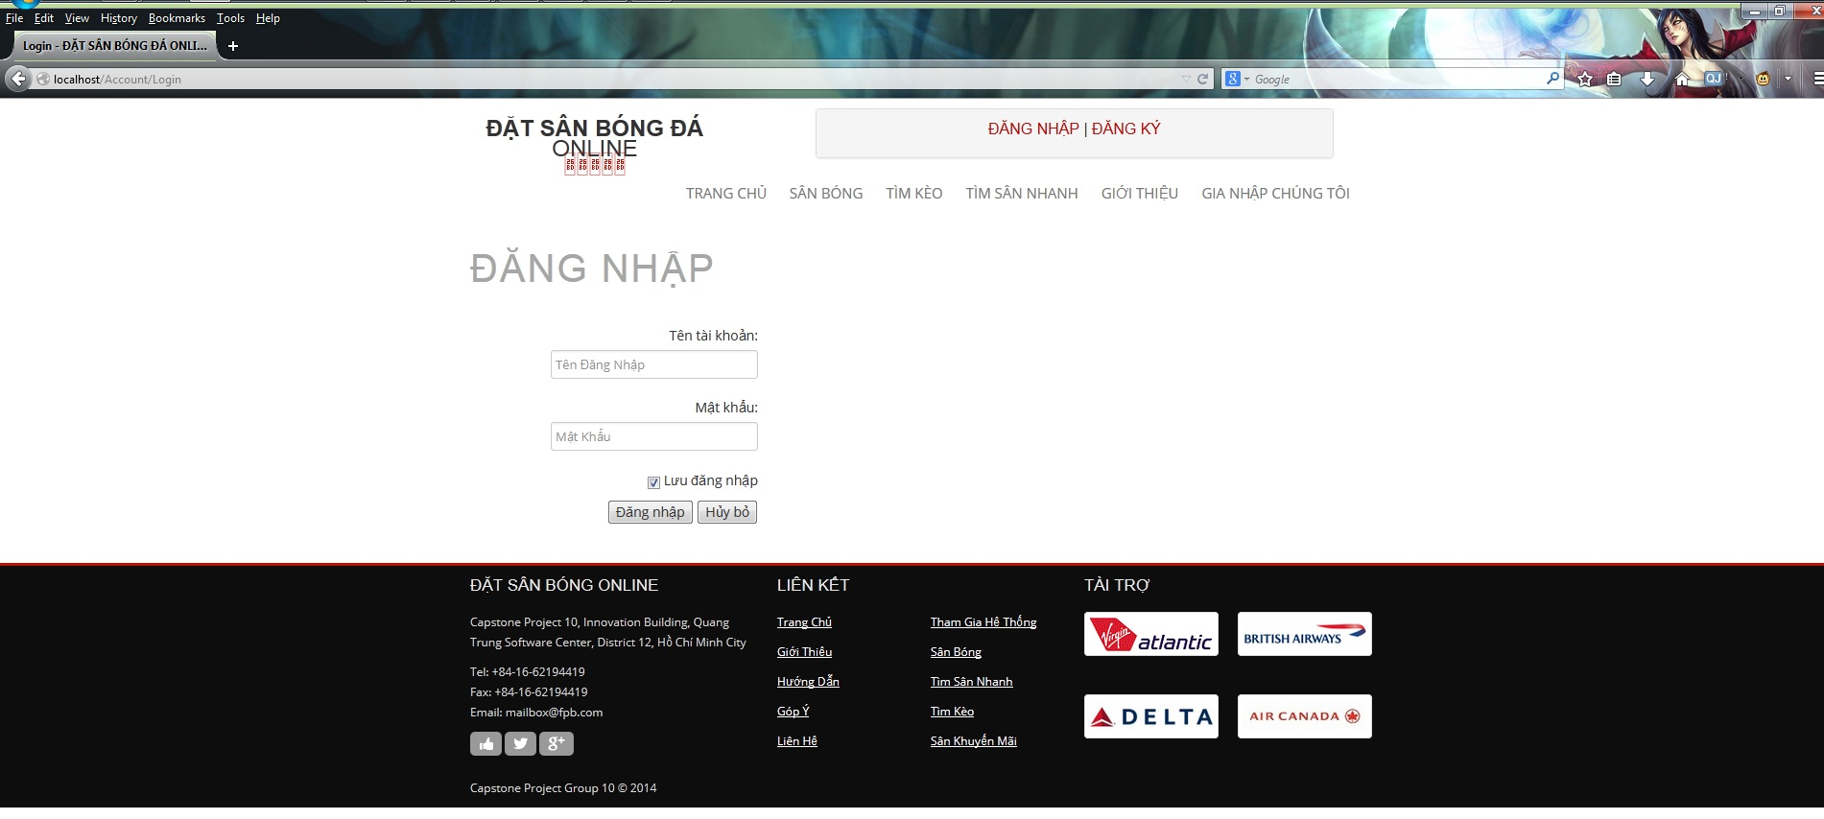

Figure 6.8 Website is deployed

### 6.2 User’s Guide

### 6.2.1. Website Master

- Step 1 : Login with WebsiteMaster role

- Step 2 : Click “Quản Trị Website” link in Admin page

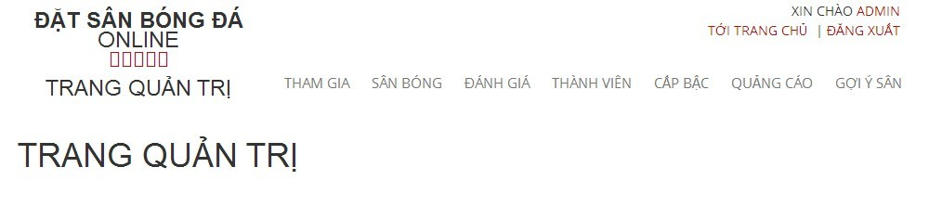

Figure 6.9 Website Staff

#### 6.2.1.1. Join Request Management

##### 6.2.1.1.1 View All Join Request

- Step 1 : Click “ Tham Gia “ link to view all join request from member

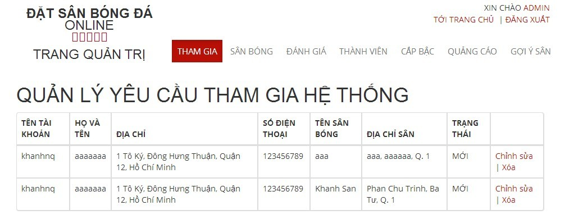

#### 6.2.1.2. Stadium Management

##### 6.2.1.2.1 View All Stadiums

- Step 1 : Click “ Sân Bóng “ link to view all stadiums

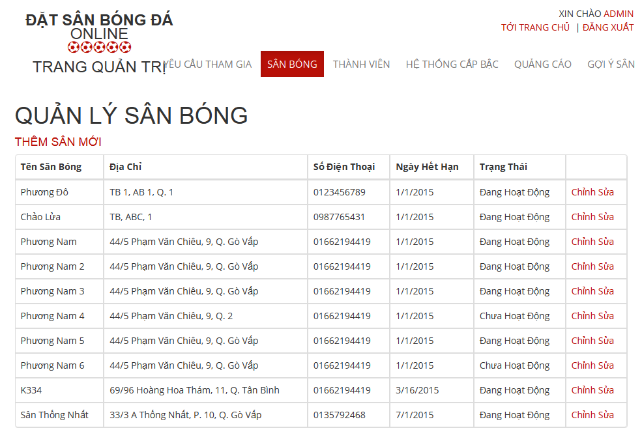

Figure 6.10 View All Stadiums

##### 6.2.1.2.2 Add New Stadium

- Step 1 : Click “ Thêm Sân Mới “ link

- Step 2 : Input all required fields

- Step 3 : Click“ Thêm Sân Mới” button to add new stadium or click “ Hủy Bỏ “ button to cancel

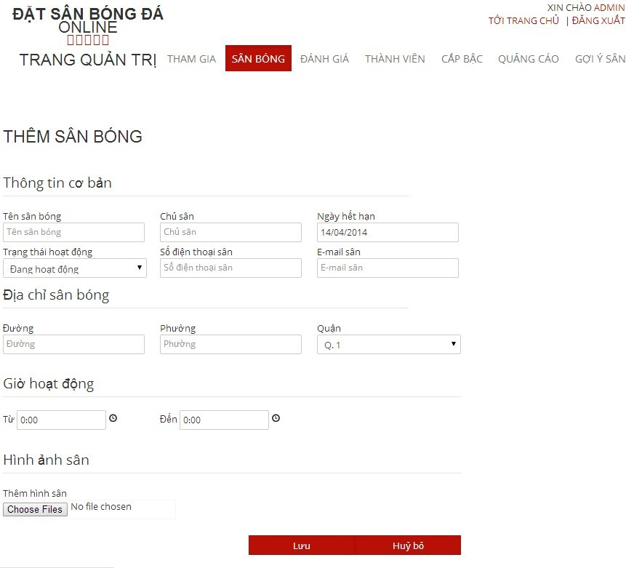

Figure 6.11 Add New Stadium

##### 6.2.1.2.3 Edit Stadium

- Step 1 : Click “ Chỉnh Sửa “ link

- Step 2 : Change information of field which you want to change

- Step 3 : : Click“ Lưu” button to save the information of member or click “ Hủy Bỏ “ button to cancel



Figure 6.12 Edit Stadium

#### 6.2.1.3. User Management

##### 6.2.1.3.1 View List Members

- Step 1: Choose “ Thành Viên “ link to view all members of the website

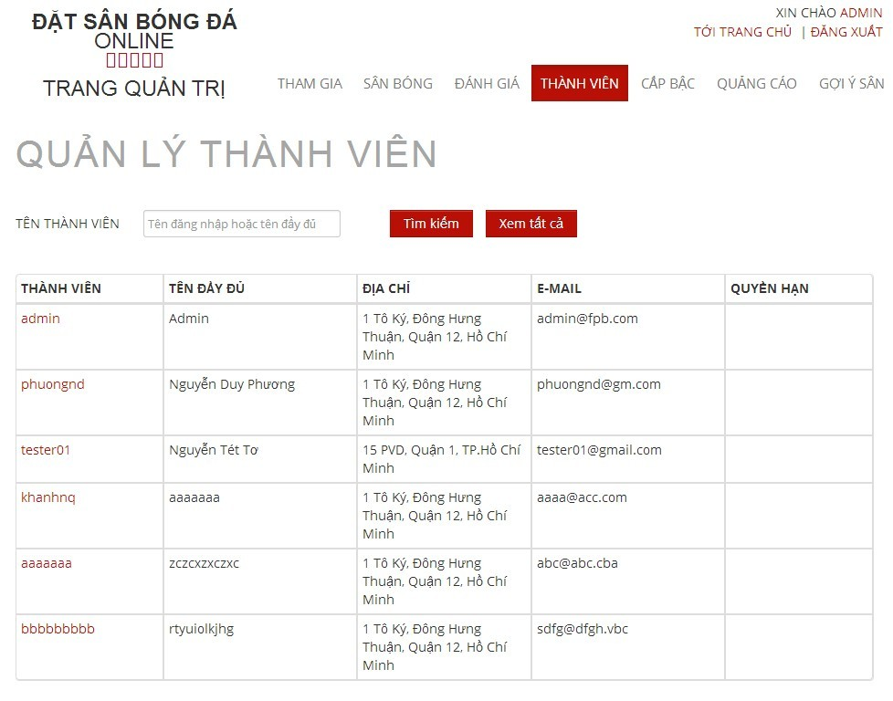

Figure 6.13 View Add Users

##### 6.2.1.3.2 Search Members

- Step 1 : Click the textbox beside Search Button in “ Quản Lý Người Sử Dụng “ page

- Step 2 : Input name of member you want to find

- Step 3 : Click“ Tìm Kiếm “ button to find

- Step 4 : Click“ Làm Mới “ to refresh member list.

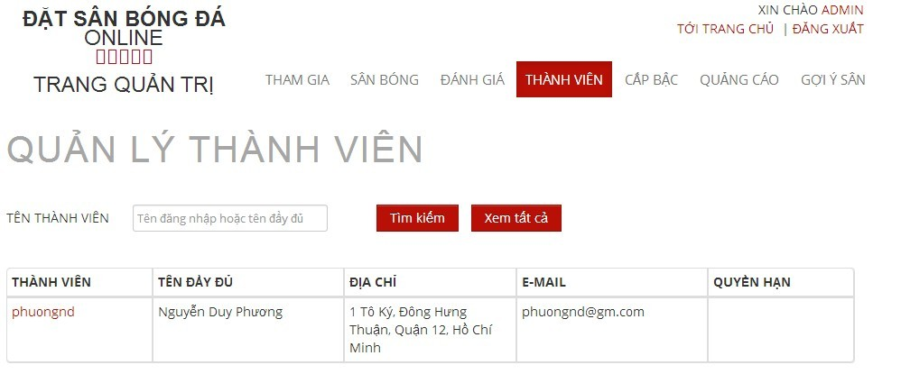

Figure 6.14 Search User

##### 6.2.1.3.3 Edit Members

- Step 1 : Click name of the member you want to change information

- Step 2 : Change information of field which you want to change

- Step 3 : Click “ Cập Nhật” button to save the information of member or click “ Hủy Bỏ “ button to cancel

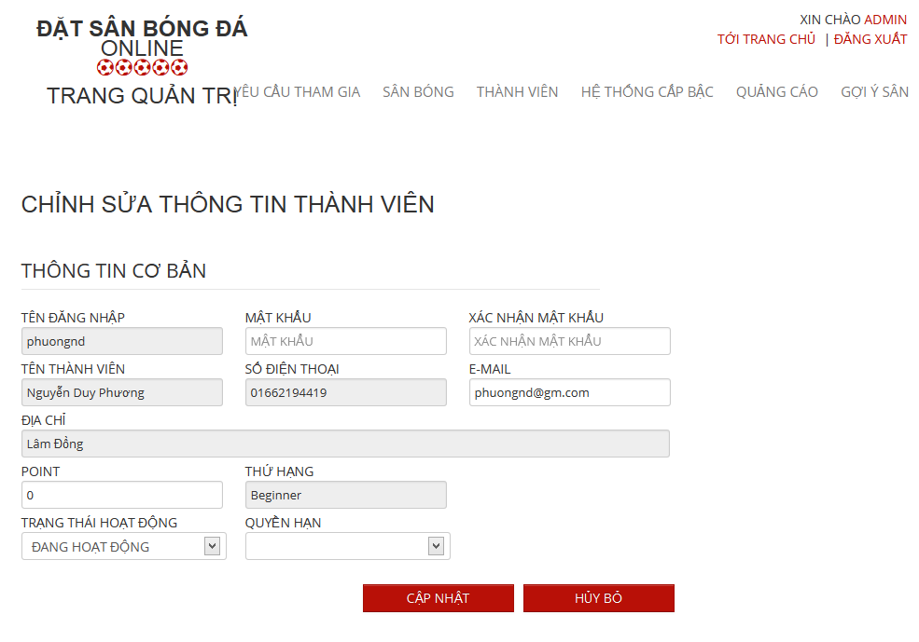

Figure 6.15 Edit User

#### 6.2.1.4. Advertise Management

##### 6.2.1.4.1 View All Advertises

- Step 1 : Click “ Quảng Cáo “ link to view all advertises

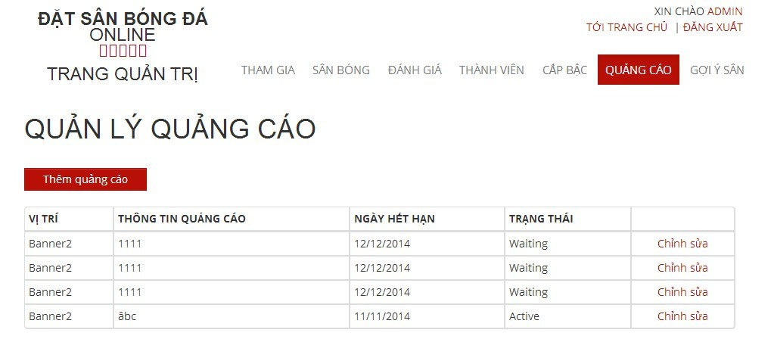

##### 6.2.1.4.2 Add New Advertises

- Step 1 : Click “ Thêm Quảng Cáo “ button in “ Quảng Cáo “ page

- Step 2: Input in all required fields

- Step 3: Click “ Lưu” button to add new advertise or click “ Hủy Bỏ “ button to cancel

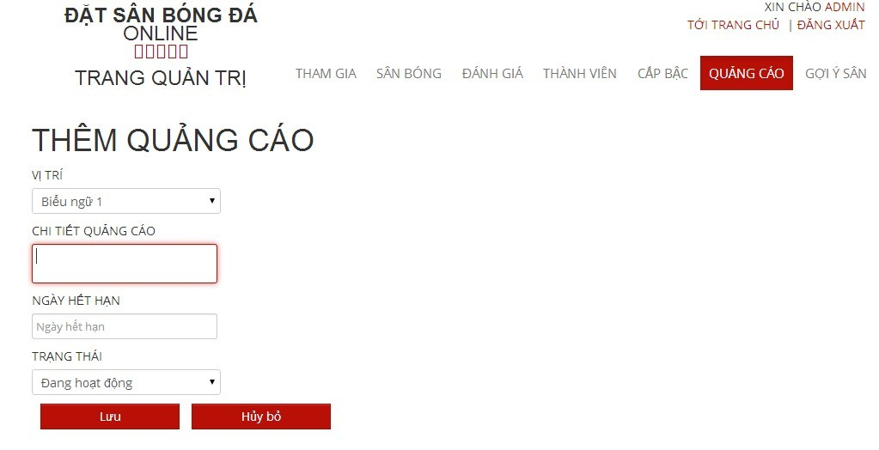

#### 6.2.1.5 Recommendation Management

##### 6.2.1.5.1 View Recommendation Management Page

- Step 1 : Click “ Gợi Ý Sân “ link

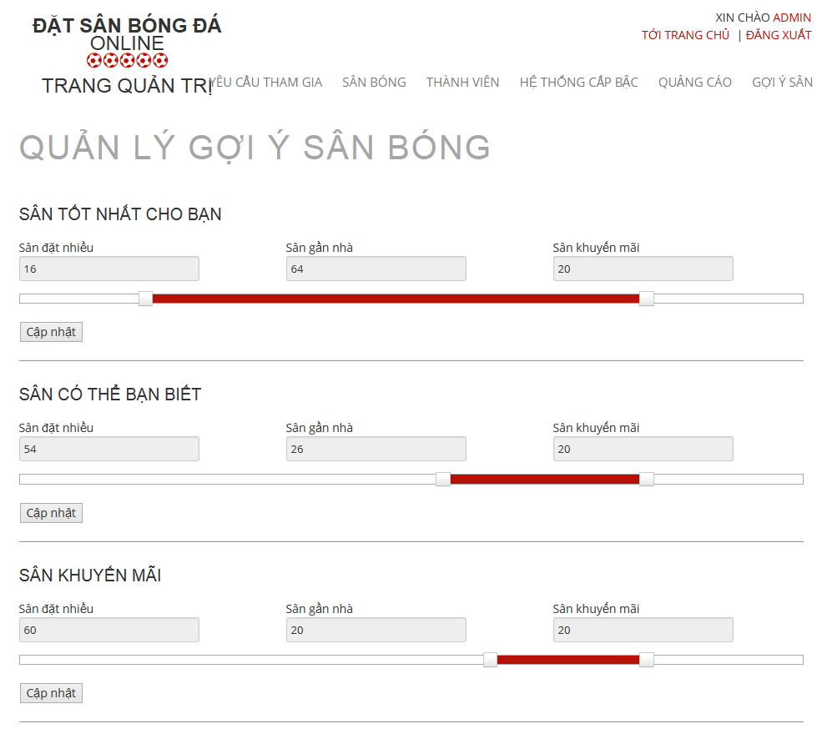

Figure 6.20 Recommendation Management

##### 6.2.1.5.2 Edit in Recommendation Management Page

- Step 1 : Drag on the point to change the value of each priority

- Step 2 : Click “ Cập Nhật “ button to save

#### 6.2.1.6 Ranks Management

##### 6.2.1.6.1 View List Ranks

- Step 1: Choose “ Hệ Thống Cấp Bậc “ link to view all memberranks of the website

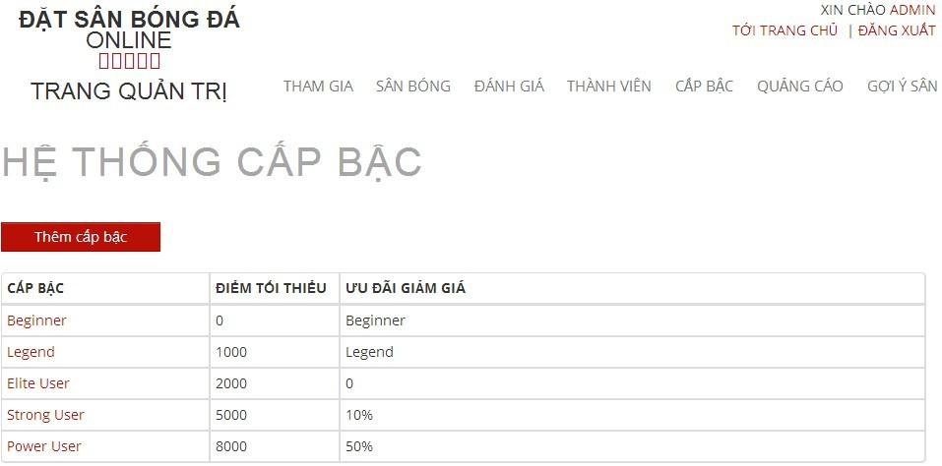

##### 6.2.1.6.2 Add Ranks

- Step 1 : Click “ Thêm Thứ Hạng “ link in “ Hệ Thống Cấp Bậc “ page

- Step 2: Input in all required fields

- Step 3: Click “ Lưu” button to add new memberrank or click “ Hủy Bỏ “ button to cancel

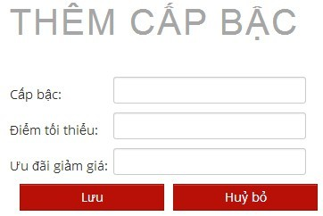

##### 6.2.1.6.3 Edit Ranks

- Step 1 : Click name of rank in “ Hệ Thống Cấp Bậc “ page which you want to edit

- Step 2 : Change information which field you want to change result

- Step 3: Click “Lưu” button to save the rank or click “ Hủy Bỏ “ button to cancel or “ Xóa cấp bậc “ button to delete rank

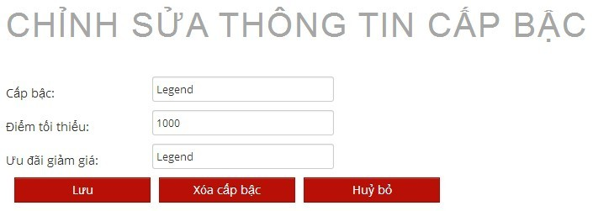

##### 6.2.1.6.4 Delete Ranks

- Step 1 : Click name of rank in “ Hệ Thống Cấp Bậc “ page which you want to delete

- Step 2 : Click “ Xóa cấp bậc “ button to delete rank

### 6.2.2 Website Staff

- Step 1 : Login with WebsiteStaff role

- Step 2 : Click “Quản Trị Website” link

#### 6.2.2.1. User Management

##### 6.2.2.1.1 View List Members

- Step 1: CLick “ Thành Viên “ link to view all members of the website



Figure 6.13 View Add Users

##### 6.2.2.1.2 Search Members

- Step 1 : Click the textbox beside Search Button in “ Quản Lý Người Sử Dụng “ page

- Step 2 : Input name of member you want to find

- Step 3 : Click“ Tìm Kiếm “ button to find

- Step 4 : Click“ Làm Mới “ to refresh member list.



Figure 6.14 Search User

##### 6.2.2.1.3 Edit Members

- Step 1 : Click name of the member who you want to change information

- Step 2 : Change information of field which you want to change

- Step 3 : Click “ Cập Nhật” button to save the information of member or click “ Hủy Bỏ “ button to cancel



Figure 6.15 Edit User

### 6.2.3 Stadium Staff

- Step 1 : Login with Stadium Staff role

- Step 2 : Click “Quản Lý Sân Bóng ” link

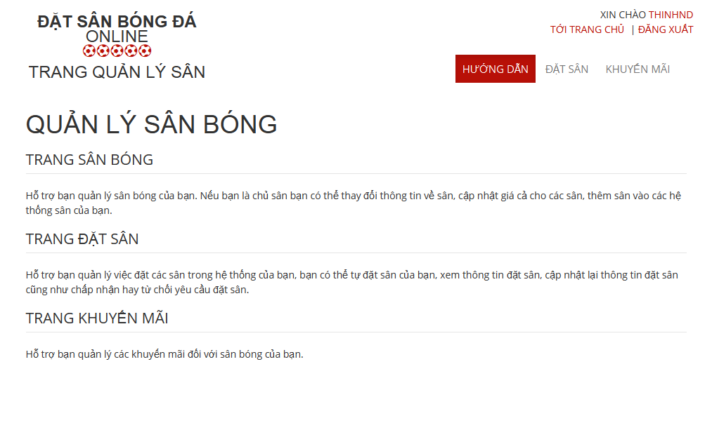

#### 6.2.3.1 Promotion Management

##### 6.2.3.1.1. View List Promotions

- Step 1: Click “Khuyến mãi” link in “ Quản lý sân “ page

- Step 2: Choose Stadium to view promotions of that stadium

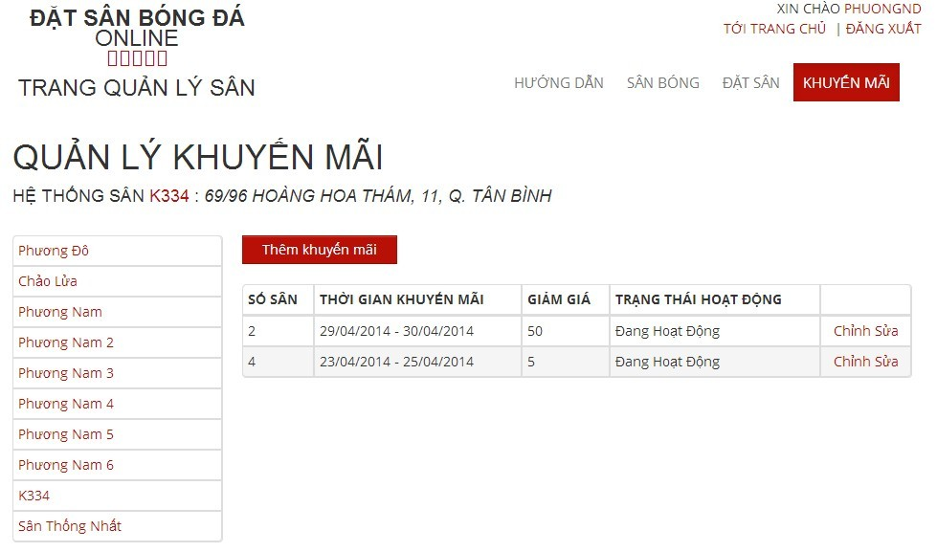

##### 6.2.2.1.2. Add New Promotion

- Step 1: Click “Thêm khuyến mãi” button from “ Thêm khuyến mãi “page

- Step 2: Input information about promotion

- Step 3: Click “Lưu” button to save or click “Hủy bỏ” to cancel

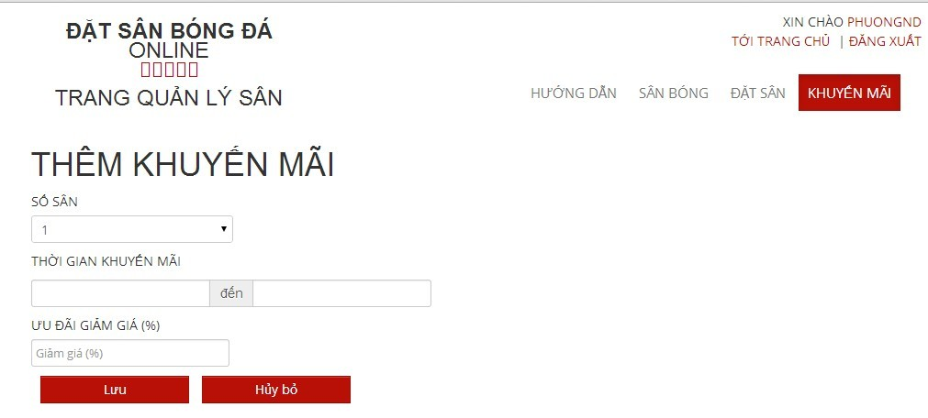

##### 6.2.3.1.3. Edit Promotion

- Step 1: Click “Chỉnh sửa” link on which promotion you want to edit

- Step 2: Change information about that promotion

- Step 3: Click “Lưu” button to save or click “Hủy bỏ” to cancel

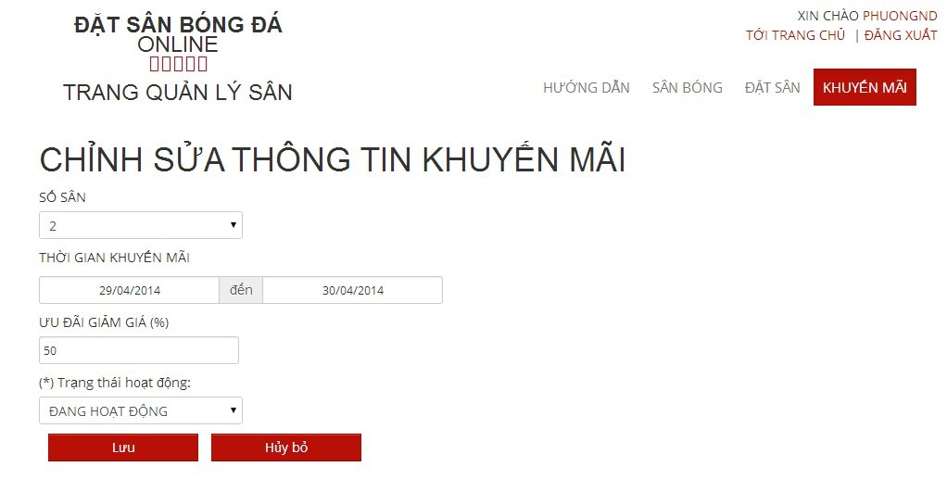

#### 6.2.3.2 Reservation Management

##### 6.2.3.2.1 View All Reservations :

- Step 1 : Click “ Đặt Sân “ link to view all reservations

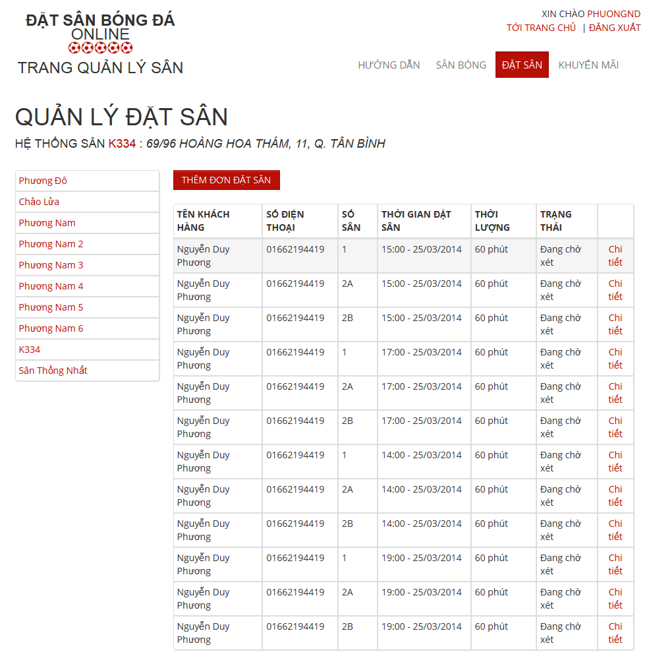

##### 6.2.3.2.2 Add New Reservation

- Step 1 : Click “ Thêm Đơn Đặt Sân “ button in “ Quản Lý Đặt Sân “ page

- Step 2: Input in all required fields

- Step 3: Click “ Lưu” button to add new price list or click “ Hủy Bỏ “ button to cancel

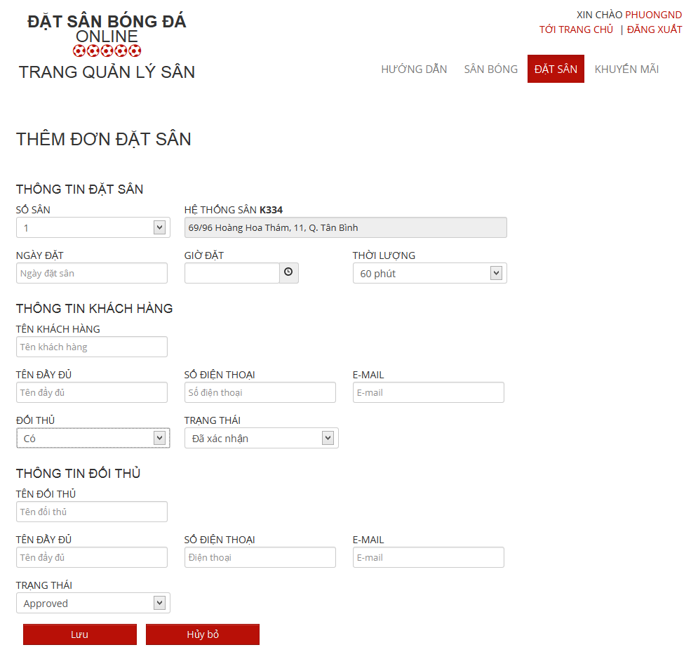

##### 6.2.3.2.3 Confirm Reservation

- Step 1 : Click “ Chi tiết “ link of the reservation which you want to examine

- Step 2 : Click “Xác Nhận” button to confirm or Click “Từ Chối” to deny or Click “ Chỉnh Sửa “ to edit reservation or Click “ Quay Lại “ to cancel

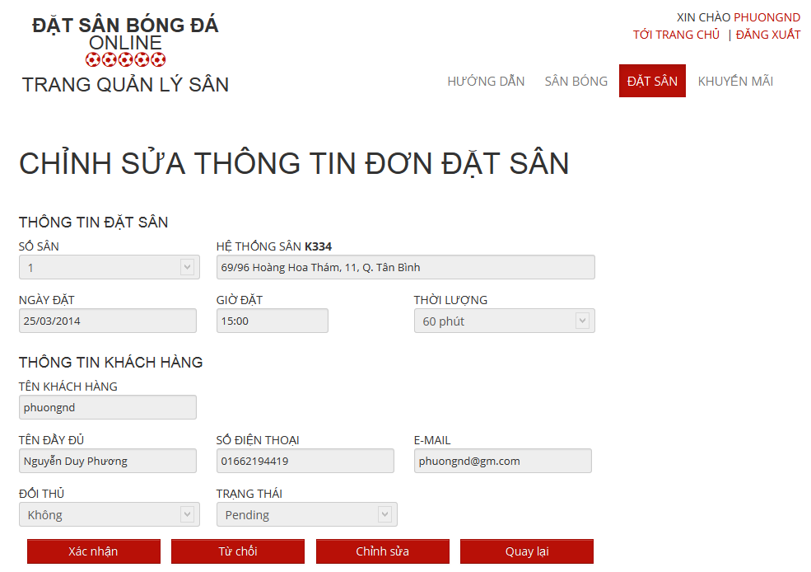

##### 6.2.3.2.4.1 Edit Reservation

- Step 1 : Click “ Chỉnh Sửa “ button to edit reservation which you want to change

- Step 2: Change information about that reservation

- Step 3: Click “Lưu” button to save or click “Hủy bỏ” to cancel

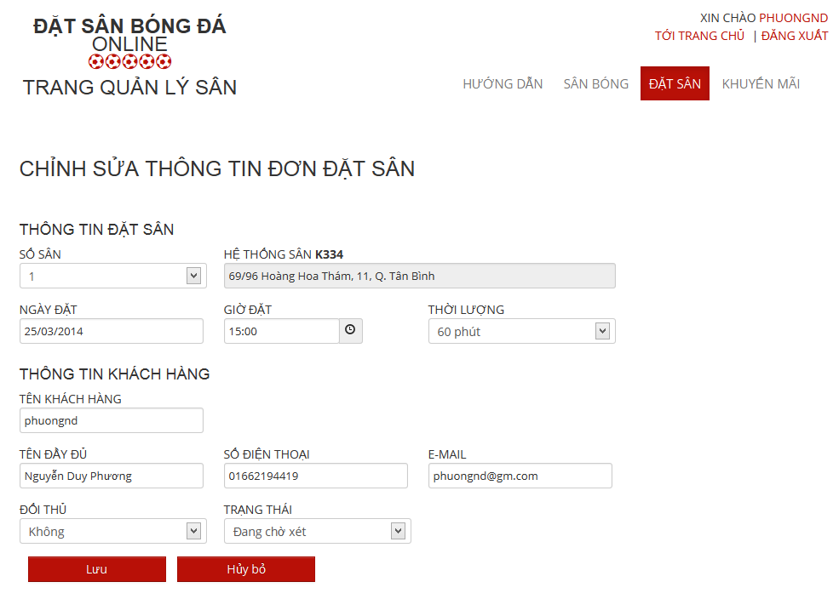

### 6.2.4 Stadium Owner

- Step 1 : Login with StadiumOwner role

- Step 2 : Click “Quản Trị Sân Bóng” link

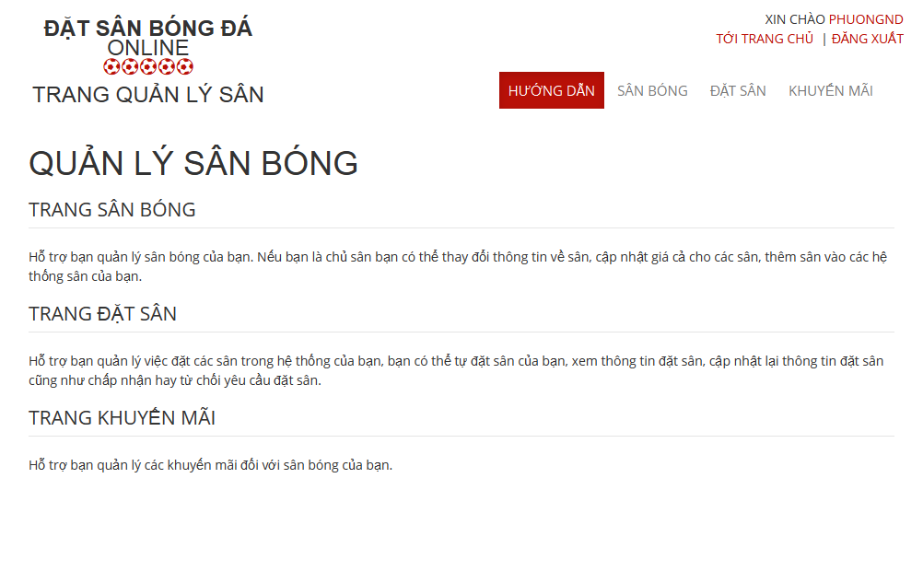

#### 6.2.4.1 Stadium Management

##### 6.2.4.1.1 View All Stadiums

-Step 1 : Click “ Sân Bóng “ link

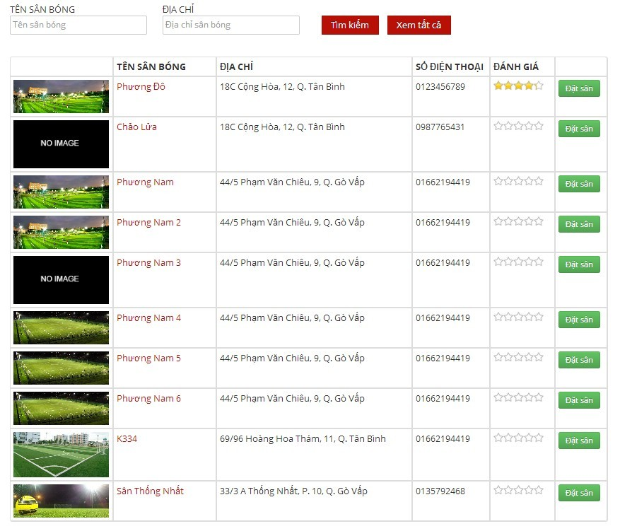

##### 6.2.4.1.2 Edit Stadium

- Step 1 : Click “ Chỉnh sửa “ link of the stadium which you want to change

- Step 2 : Change information of field which you want to change

- Step 3 : Click “ Chọn Hình Ảnh “ button to choose new image about this stadium

- Step 4 : Click “Lưu ” button to save or click “Hủy bỏ” to cancel

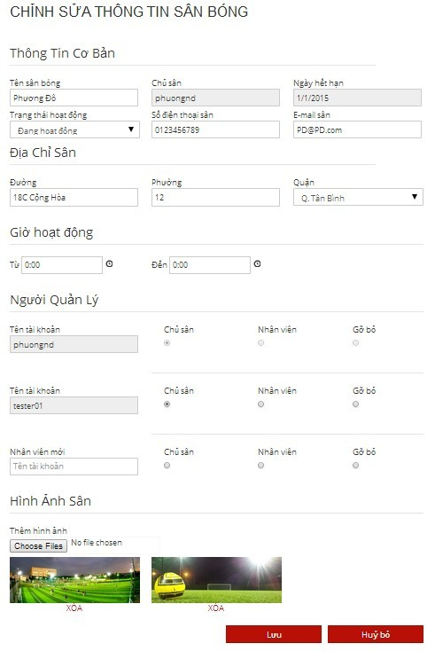

##### 6.2.4.1.3 View Child Field

- Step 1 : Click “ Sân Con “ link to see all child fields of this stadium

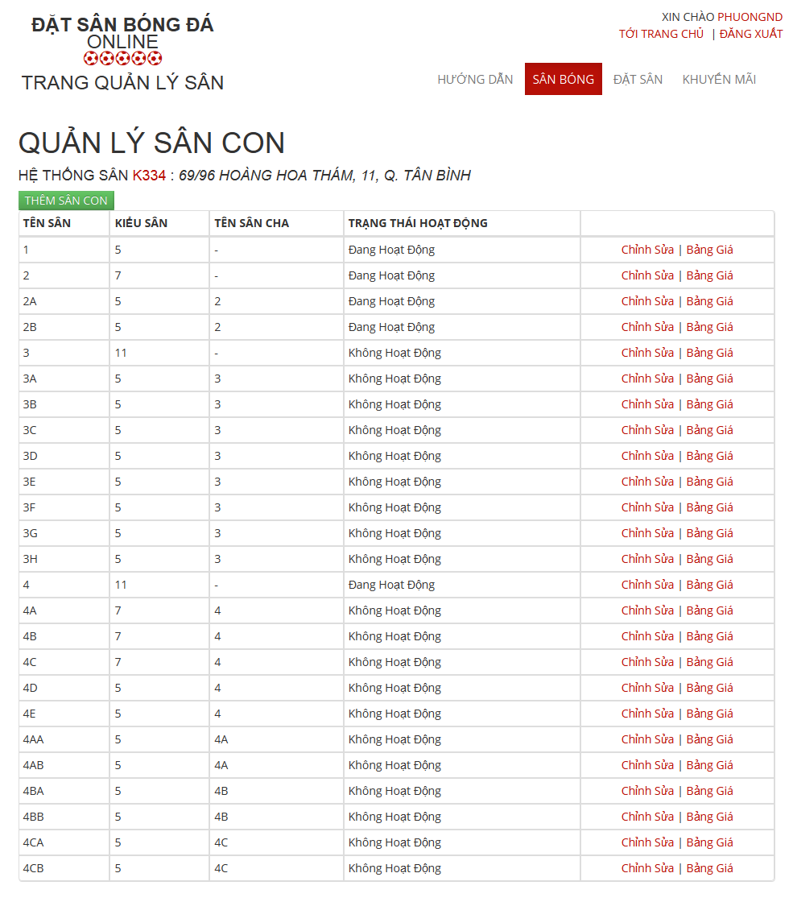

##### 6.2.4.1.3.1 Add New Child Field

- Step 1 : Click “ Thêm Sân Con “ button in “ Quản Lý Sân Con “ Page

- Step 2: Input in all required fields

- Step 3: Click “ Lưu” button to add new child field or click “ Hủy Bỏ “ button to cancel

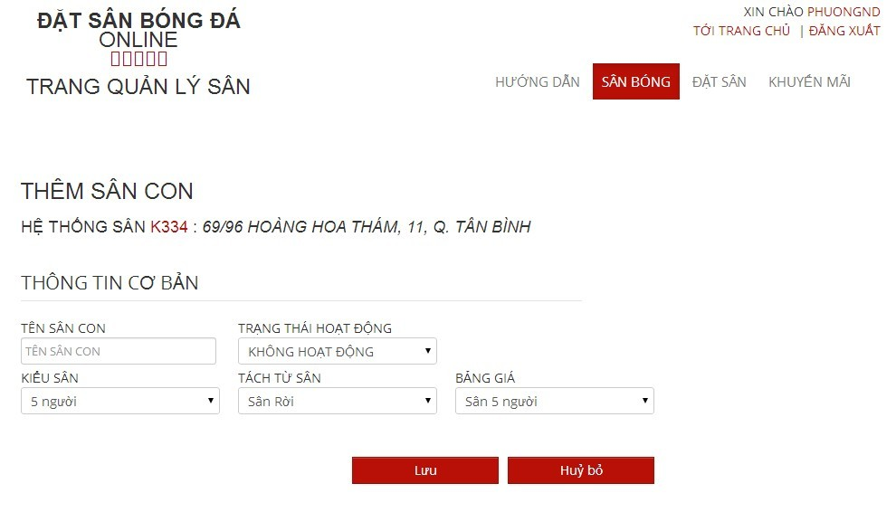

##### 6.2.4.1.3.2 Edit Child Field

- Step 1 : Click “ Chỉnh sửa “ link of the child field which you want to change

- Step 2 : Change information of field which you want to change

- Step 3 : Click “Lưu” button to save or click “Hủy bỏ” to cancel

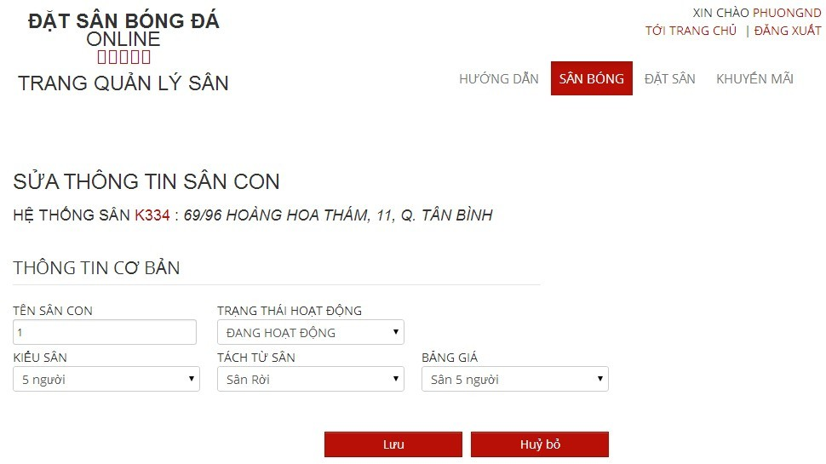

##### 6.2.4.1.3.3 View Price List of Child Filed

- Step 1 : Click “ Bảng Giá “ link of the child field which you want to see

##### 6.2.4.1.4 View Price List

- Step 1 : Click “ Bảng Giá “ link to see all child fields of this stadium

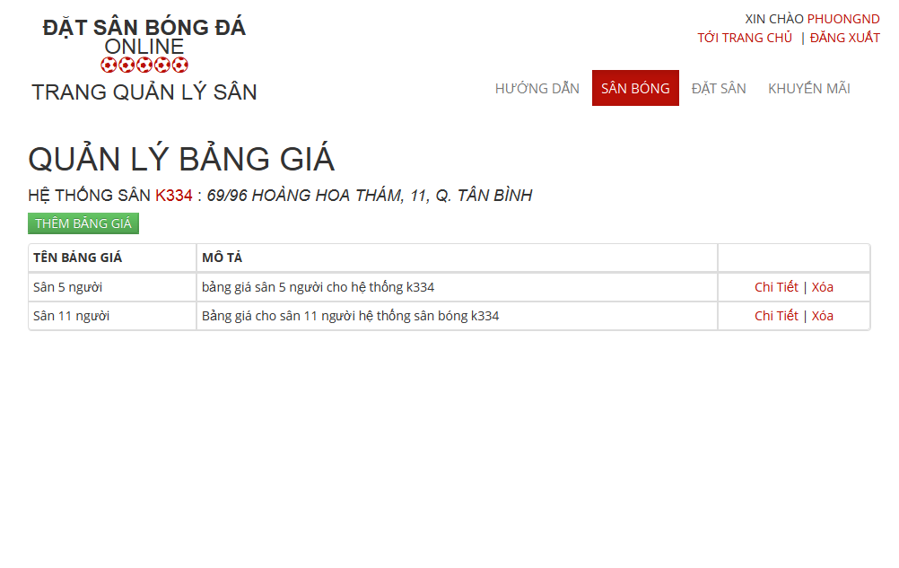

##### 6.2.4.1.4.1 Add New Price List

- Step 1 : Click “ Thêm Bảng Giá “ button in “ Quản Lý Bảng Giá“ Page

- Step 2: Input in all required fields

- Step 3: Click “ Lưu” button to add new price list or click “ Hủy Bỏ “ button to cancel

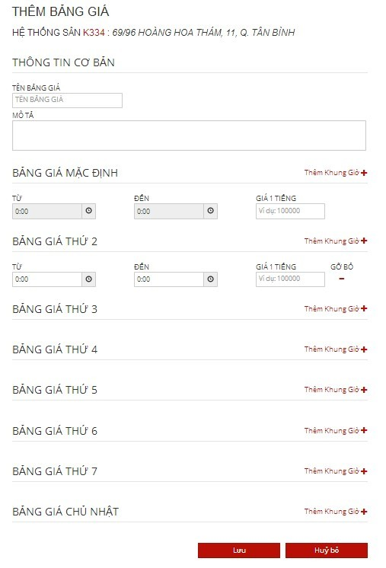

#### 6.2.4.2 Promotion Management

##### 6.2.4.2.1. View List Promotions

- Step 1: Click “Khuyến mãi” link in “ Quản lý sân “ page

- Step 2: Choose Stadium to view promotions of that stadium



##### 6.2.4.2.2. Add New Promotion

- Step 1: Click “Thêm khuyến mãi” button from “ Thêm khuyến mãi “page

- Step 2: Input information about promotion

- Step 3: Click “Lưu” button to save or click “Hủy bỏ” to cancel



##### 6.2.4.2.3. Edit Promotion

- Step 1: Click “Chỉnh sửa” link on which promotion you want to edit

- Step 2: Change information about that promotion

- Step 3: Click “Lưu” button to save or click “Hủy bỏ” to cancel



#### 6.2.4.3 Reservation Management

##### 6.2.4.3.1 View All Reservations :

- Step 1 : Click “ Đặt Sân “ link to view all reservations



##### 6.2.4.3.2 Add New Reservation

- Step 1 : Click “ Thêm Đơn Đặt Sân “ button in “ Quản Lý Đặt Sân “ page

- Step 2: Input in all required fields

- Step 3: Click “ Lưu” button to add new price list or click “ Hủy Bỏ “ button to cancel



##### 6.2.4.3.3 Confirm Reservation

- Step 1 : Click “ Chi tiết “ link of the reservation which you want to examine

- Step 2 : Click “Xác Nhận” button to confirm or Click “Từ Chối” to deny or Click “ Chỉnh Sửa “ to edit reservation or Click “ Quay Lại “ to cancel



##### 6.2.4.3.4.1 Edit Reservation

- Step 1 : Click “ Chỉnh Sửa “ button to edit reservation which you want to change

- Step 2: Change information about that reservation

- Step 3: Click “Lưu” button to save or click “Hủy bỏ” to cancel



### 6.2.5 User

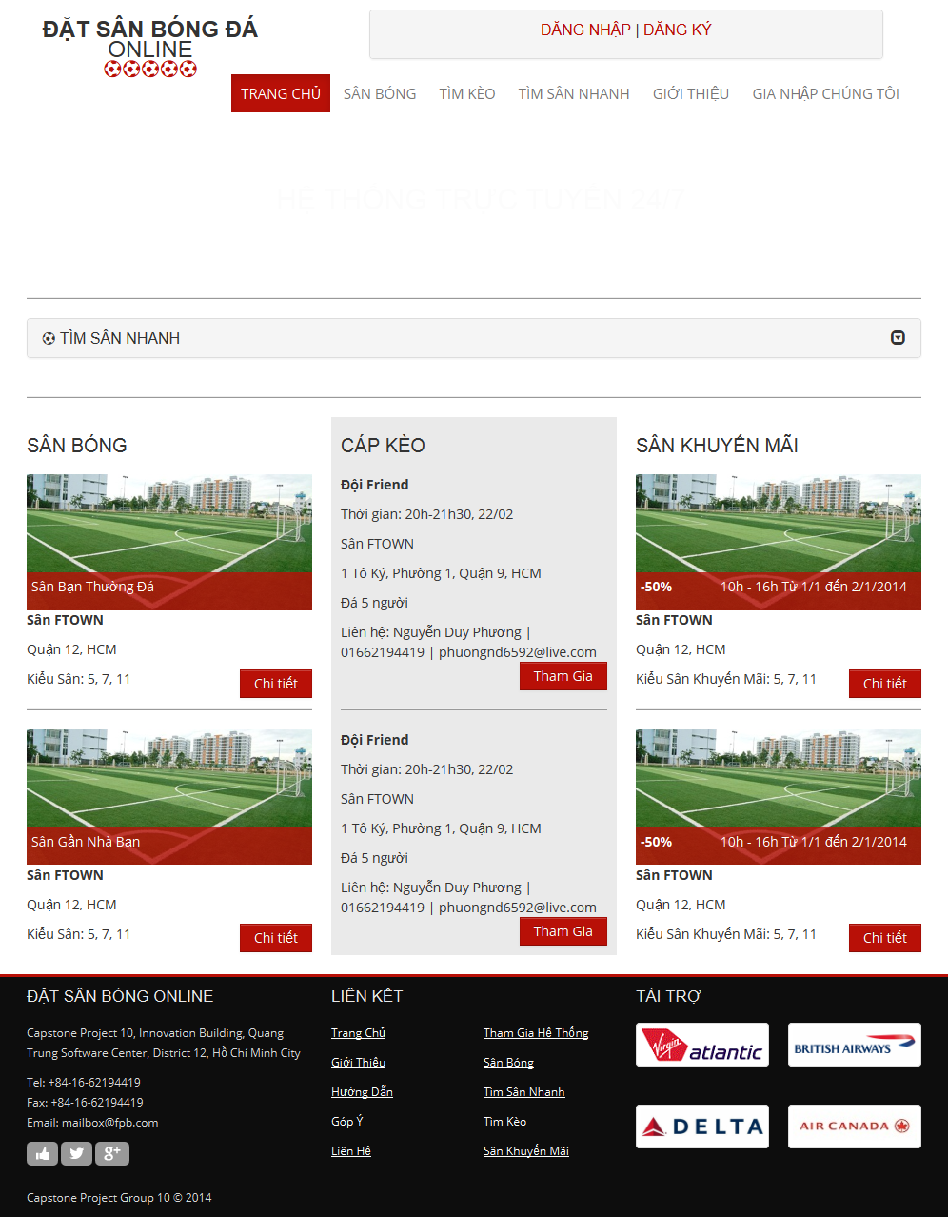

#### 6.2.5.1. Register

- Step 1: Click “Đăng ký” link on “ Trang chủ “ page.

- Step 2: Input all required field

- Step 3: Click “Đăng ký” button to register, or click “ Hủy Bỏ “ button to cancel

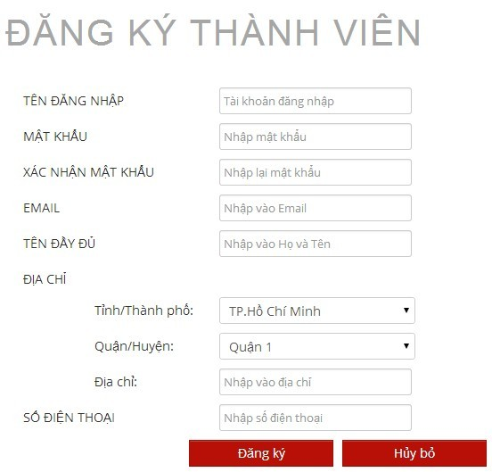

#### 6.2.5.2. Login

- Step 1: Click “Đăng nhập” link on “ Trang chủ “ page

- Step 2: Input username and password

- Step 3: Click “Đăng nhập” button

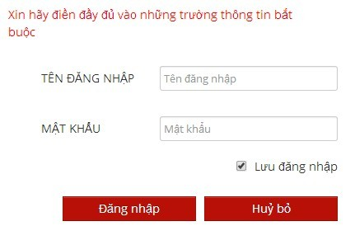

#### 6.2.5.3. View Account Profiles

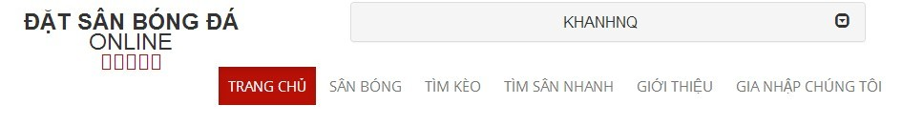

* Step 1: Click username link to open management window
* Step 2: Click “Quản lý tài khoản” link

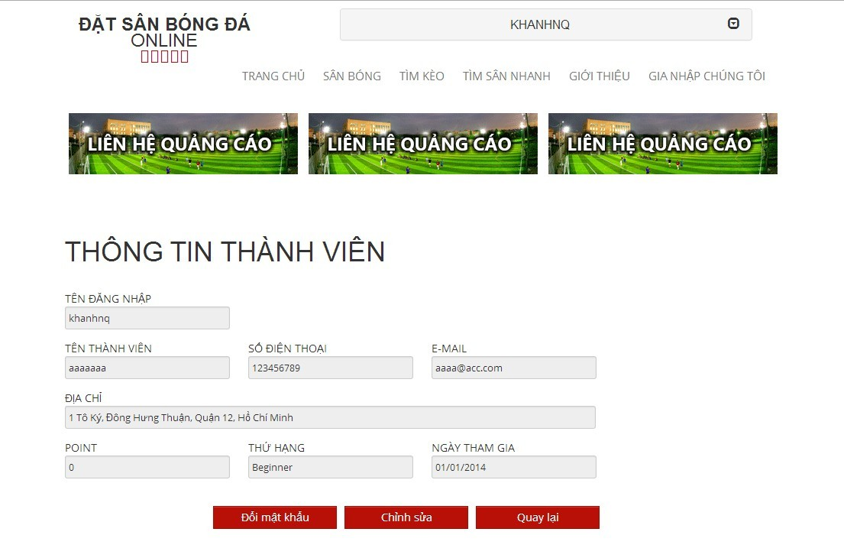

#### 6.2.5.4. Edit Account Profiles

- Step 1: Click “Chỉnh sửa” button from “ Thông tin thành viên “ page

- Step 2: Change account profiles information

- Step 3: Click “Lưu” to save or click “Hủy bỏ” to cancel and redirect to “ Thông tin thành viên “ page

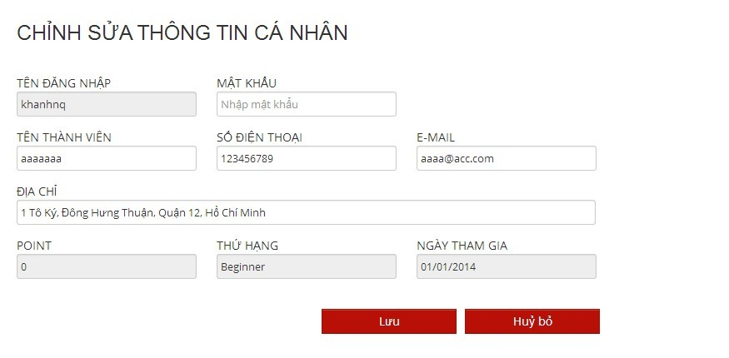

Change Password:

* Step 1: Click “Đổi mật khẩu” button from view account profiles page
* Step 2: Input old and new password, confirm password
* Step 3: Click “Lưu” button to save new password or click “ Hủy Bỏ “ button to cancel and back to view account profiles page

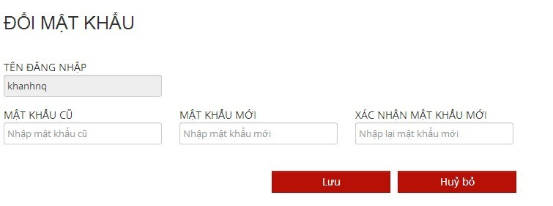

#### 6.2.5.5. Find Available Stadium

- Step 1: Click “Tìm sân nhanh” link or open “Tìm sân nhanh” drop down list at “ Trang chủ “ page

- Step 2: Choose information

- Step 3: Click “Tìm kiếm” button to find available stadium

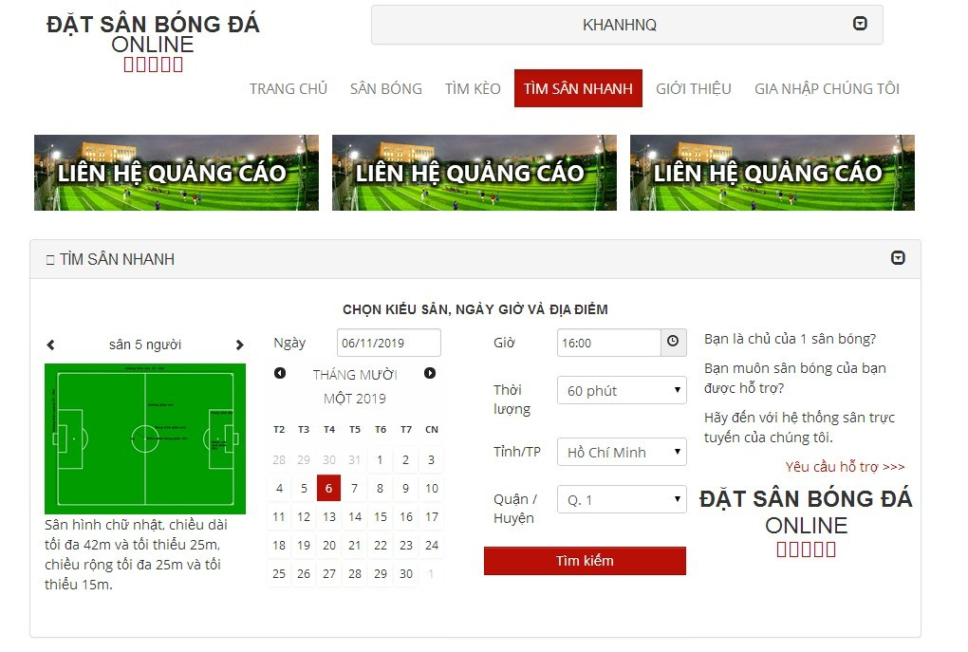

#### 6.2.5.6. Find Stadium

- Step 1 : Click “ Sân bóng “ link in “ Trang chủ “ page

- Step 2 : Input all information about the stadium you want to find

- Step 3 : Click “ Tìm Kiếm “ button to find

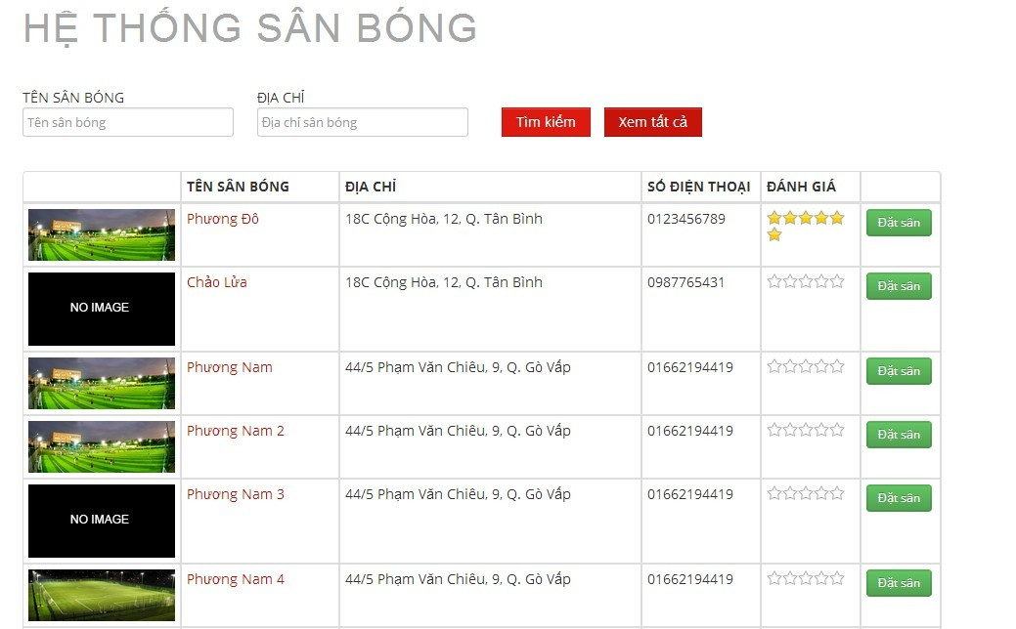

#### 6.2.5.7. View Stadium Details

- Step 1 : Click “ Sân Bóng “ link in “ Trang chủ “ page

- Step 2 : Click a stadium you want to view information

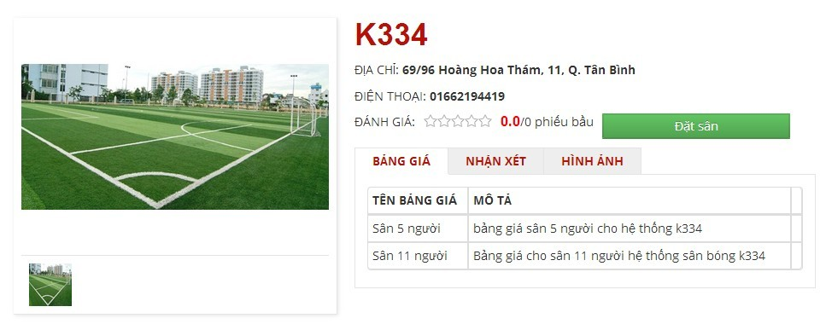

#### 6.2.5.8. Rating Stadium

- Step 1 : Click “ Sân Bóng “ link in “Trang chủ “ page

- Step 2 : Click a stadium which you want to rate

- Step 3 : Click 1 – 5 star for rating stadium

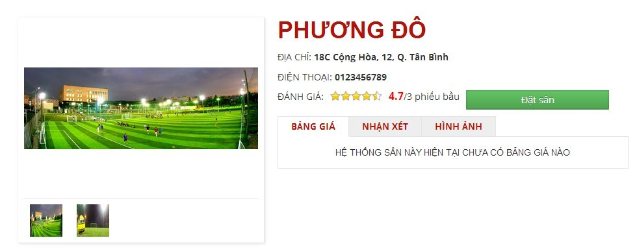

#### 6.2.3.9. Review Stadium

- Step 1 : Click “ Sân Bóng “ link in “Trang chủ “ page

- Step 2 : Click the stadium you want to review information

- Step 3 : Click 3 Tabs : “ Bảng Giá “, “ Nhận Xét “ , “ Hình Ảnh “



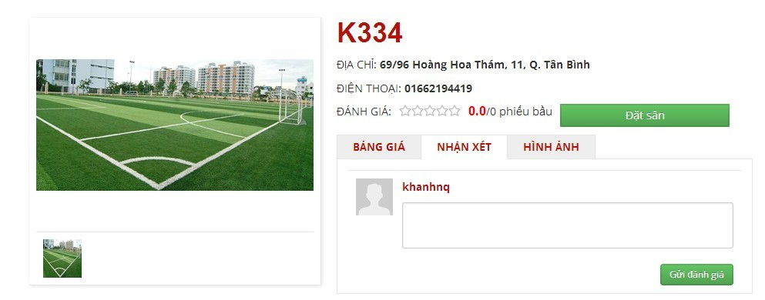

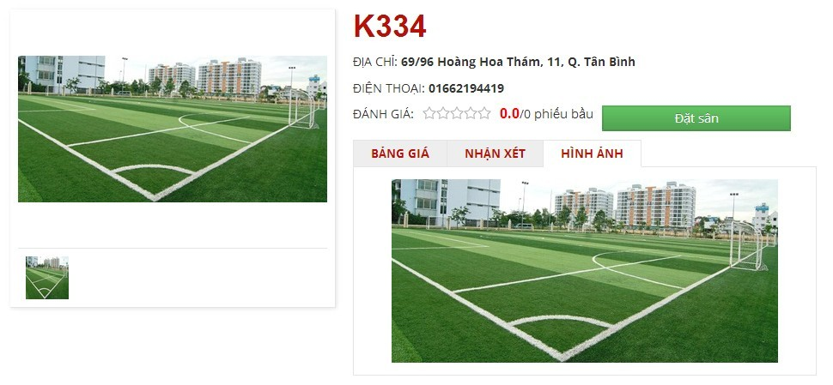

#### 6.2.3.10. Booking Pitches

- Step 1 : Click “ Sân Bóng “ link in Homepage

- Step 2 : Click “ Đặt Sân “ button on the stadium you want to book or Click the stadium which you want to book and Click “ Đặt Sân “ button

- Step 3 : Input all require information about stadium you want to book

- Step 4 : Click “ Đặt Sân “ button to book stadium or “ Hủy Bỏ “ button to cancel or “ Lưu “ button to edit “ Thông Tin Cập Nhật “

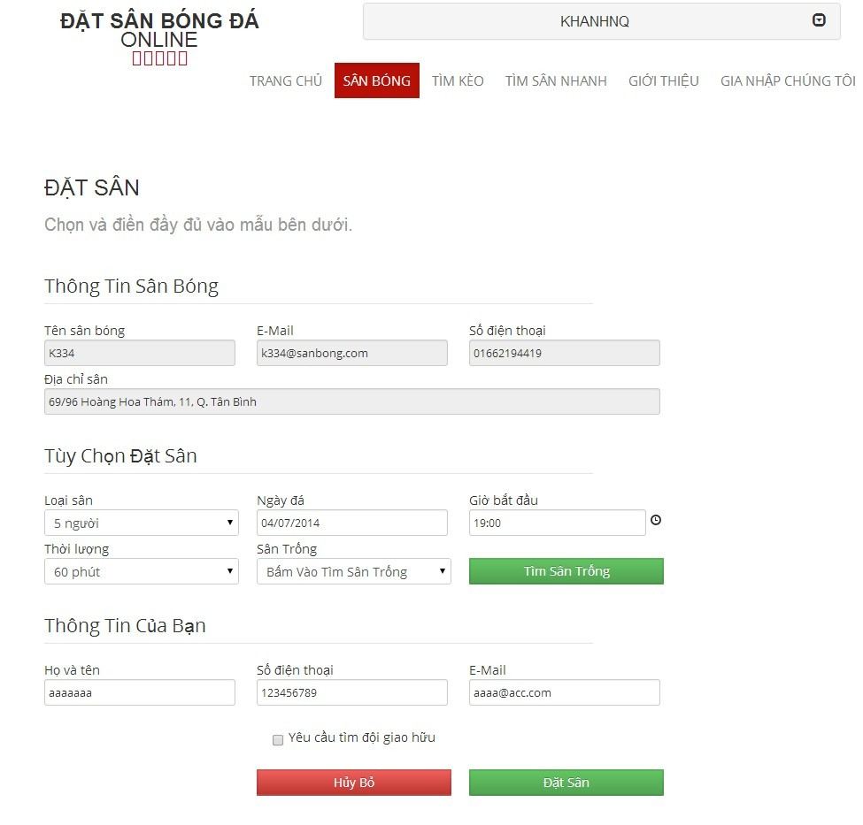

#### 6.2.3.11. Cancel Reservation

- Step 1 : Click your account

- Step 2 : Click “ Lịch Sử Đặt Sân “ link

- Step 3 : Click “ Chỉnh sửa “ link on the stadium which you want to cancel reservation

- Step 4 : Click “ Hủy Đặt Sân “ button to cancel reservation

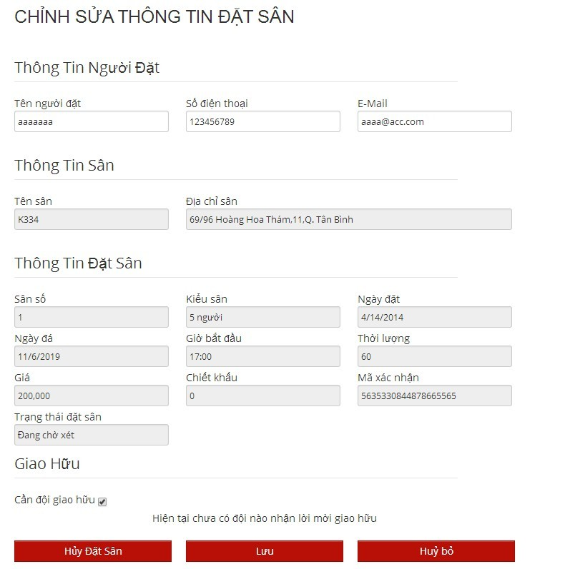

#### 6.2.3.12. Find Rival

- Step 1 : Click “ Tìm Kèo “ link in Homepage

- Step 2 : Click “ Chi tiết “ button on the team you want to fight or view information

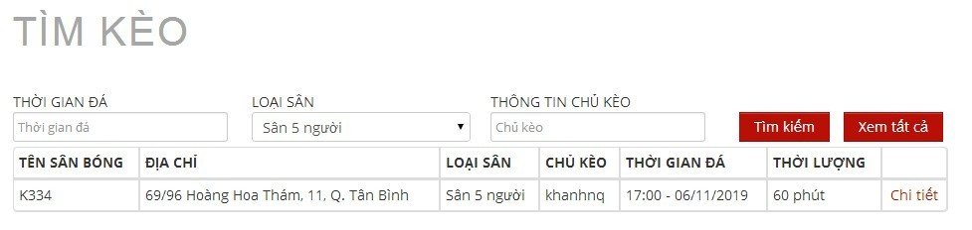

#### 6.2.3.13. Join Rival

- Step 1 : Click “ Sân bóng “ link on “ Trang chủ “ page

- Step 2 : Click " Đặt Sân " button in one stadium in list stadium or lick on one stadium and click “ Đặt sân “ button

- Step 3 : Input all information

- Step 4 : Check on “ Yêu cầu tìm đội giao hữu “ drop down list

- Step 5 : Click “ Đặt sân “ button

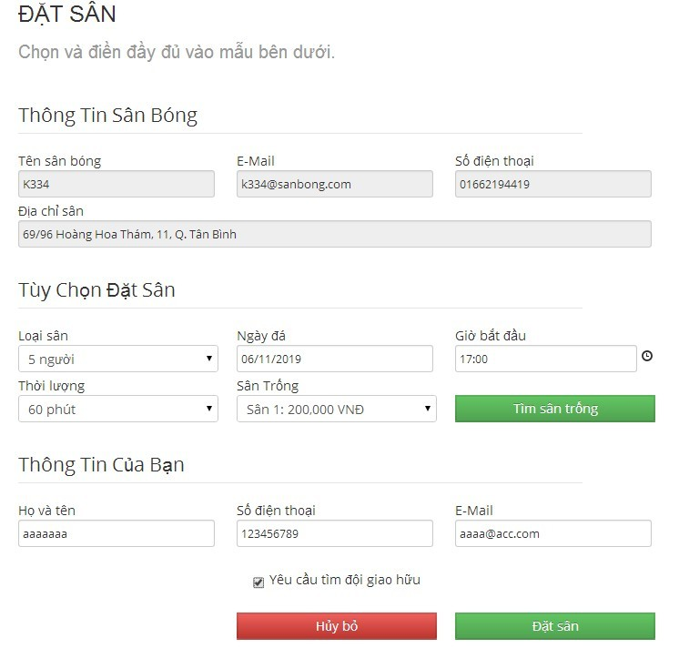

#### 6.2.3.14. View Booking History

- Step 1 : Click your account

- Step 2 : Click “ Lịch sử đặt sân “ link or Click “ Lịch sử đặt sân “ button after book field in “ Đặt sân “ page

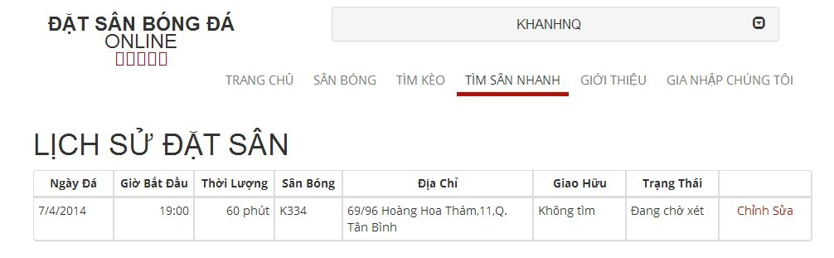

#### 6.2.5.15. Request Join System

- Step 1: Click “Gia nhập chúng tôi” link from home page

- Step 2: Input all require information

- Step 3: Click “Gửi yêu cầu” link to send this request or click “Trang chủ” link to back to home page

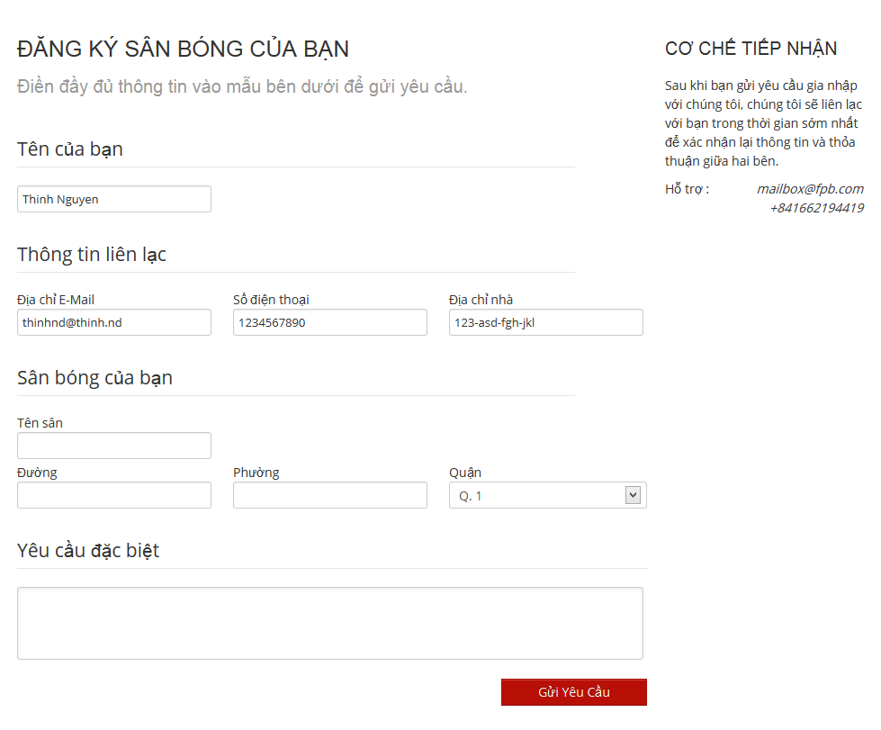

#### 6.2.5.16 Forgot Password

- Step 1 : If you forgot your password, click “ Quên mật khẩu “ link on account bar

-Step 2 : Input your email

- Step 3 : Click “ Gửi “ button to send email or click “ Hủy “ button to cancel this action

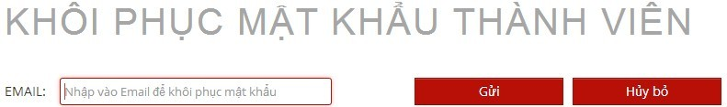

#### 6.2.5.17 Resend mail to activate Account

- Step 1 : Input “Tên đăng nhập “ and “ Mật khẩu”.

- Step 2 : Click on “ Đăng nhập “ button

- Step 3 : If your account is deactivate, an error message will be displayed, click on “ đây “ button

- Step 4 : Input your email

- Step 5 : Click “ Gửi “ button to send email or click “ Hủy “ button to cancel this action

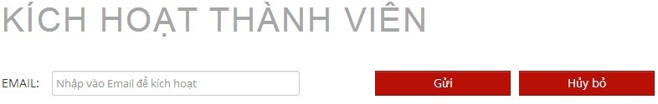

#### 6.2.5.17 Feedback Website

- Step 1 : Click “ Góp ý “ button in the end of the website to write feedback

- Step 2 : Write down your opinion

- Step 3 : Click “ Gửi “ button to send or click “ Hủy “ button to cancel feedback

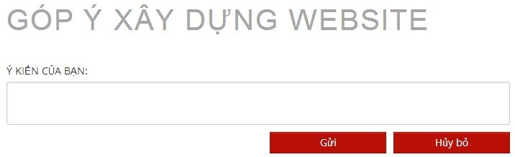

- In case, if you are guest, or not login before, feedback page will be displayed like that:

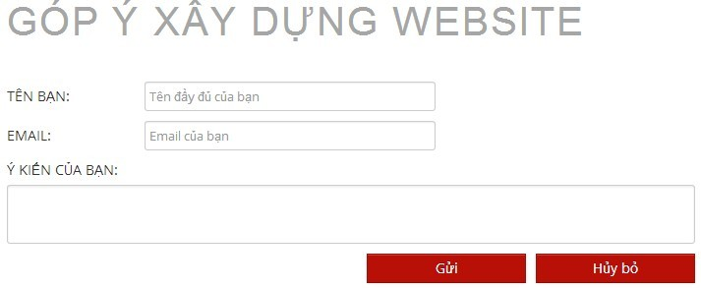

### 6.3. Other [Optional]